2nd Chapter
COMPETENCES OF LOCAL ENVIRONMENT ANIMATORS
Authors: Ľubica Černá, Daniel Markovič (NKOS)

Introduction
The terms ‘skills, abilities, knowledge and competencies’ are often used interchangeably to describe the same concepts. In general conversation this is fine, but when it comes to writing a job description, assessing candidate fit, or conducting a performance review, understanding the meaning and implication of each word becomes vital.

Knowledge
Knowledge is sometimes viewed as if it was a concrete manifestation of abstract intelligence, but it is actually the result of an interaction between intelligence (capacity to learn) and situation (opportunity to learn), so is more socially-constructed than intelligence. Knowledge includes theory and concepts and tacit knowledge gained as a result of the experience of performing certain tasks.

Ability
An ability is a talent or skill in a particular area. It can be improved or developed to a certain extent, even though it is natural and inbuilt. Its development is a lengthier and complicated process.

What does this all mean? It means that:
- we can have the knowledge of how to do something, but it doesn’t necessarily mean that we have the ability or skill to do it. This is why knowledge is the ‘simplest’ to develop. An example is: knowledge to use a word processing application.
- we need to have an ability and knowledge to develop a skill. It is difficult to develop a skill if we don’t have the ability to develop that skill. An example: skill to edit documents on the computer.
- we can have an ability to do something, but if we don’t improve on this ability, it will remain stagnant and will unlikely turn into a skill. An example: ability to understand and follow instructions.

Competence
The terms 'competency' and ‘competencies’ focus on someone’s personal attributes or inputs. They can be defined as the behaviours (and technical attributes where appropriate) that individuals must have, or must acquire, to perform effectively at work.

'Competence' and ‘competences’ are broader concepts that cover demonstrable performance outputs as well as behavioural inputs. They may relate to a system or set of minimum standards needed to perform effectively at work.

A 'competency framework' is a structure that sets out and defines each individual competency (such as problem-solving or people management) required by individuals working in an organisation or part of that organisation. Competency frameworks originally consisted mainly of behavioural elements - an expression of the softer skills involved in effective performance. They have since become broader in scope to include more technical competencies. Technology developments have given this shift greater momentum.

A competency is more than just knowledge and skills. It involves the ability to meet complex
demands, by drawing on and mobilising psychosocial resources (including skills and attitudes)
in a particular context. For example, the ability to communicate effectively is a competency that may draw on an individual’s knowledge of language, practical IT skills and attitudes towards those with whom he or she is communicating.

Key competences are context-independent, applicable and effective across different institutional settings, occupations and tasks. These typically include basal competences, such as literacy, numeracy, general education; methodological competences, like problem solving, IT skills; communication skills, including writing and presentation skills; and judgment competences, such as critical thinking.

European perspective on competences

The 2006 Recommendation of the European Parliament and of the Council on Key competences for Lifelong Learning supported the development of competence-oriented teaching and learning, and the need to reform curricula in the European Union.
In May 2018, the European Council adopted an updated Recommendation on Key Competences for Lifelong Learning to further promote the development of key competences in the European Union.

The European Framework for Key Competences for Lifelong Learning , identifies and defines 8 key competences necessary for personal fulfilment, active citizenship, social inclusion and employability in a knowledge society: 1) Communication in the mother tongue; 2) Communication in foreign languages; 3) Mathematical competence and basic competences in science and technology; 4) Digital competence; 5) Learning to learn; 6) Social and civic competences; 7) Sense of initiative and entrepreneurship; 8) Cultural awareness and expression.

The aim of the LifeComp conceptual framework is to establish a shared understanding, and a common language on the “Personal, Social and Learning to Learn” competences. LifeComp is made up of three intertwined competence areas: ‘Personal’, ‘Social’, and ‘Learning to Learn’. Each area includes three competences: Self-regulation, Flexibility, Wellbeing (Personal Area), Empathy, Communication, Collaboration (Social Area), Growth mindset, Critical thinking, and Managing learning (Learning to learn Area). Each competence has, in turn, three descriptors which generally correspond to the ‘awareness, understanding, action’ model. FIGURE 1 illustrates, at a glance, the nine competences that makeup LifeComp.
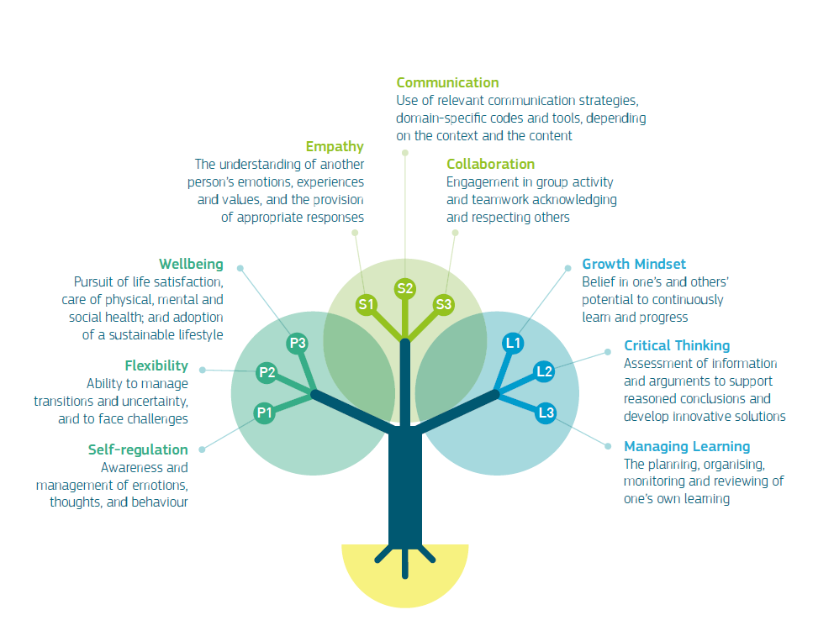

Figure 1: LifeComp framework for “personal, social and learning to learn” key competence

The European Commission has developed Green-Comp as a reference framework on sustainability competences at EU level. It provides a common ground to learners and guidance to educators, providing an agreed definition of what sustainability as a competence entails.
GreenComp consists of 12 competences organised into the four areas. GreenComp comprises four interrelated competence areas: ‘embodying sustainability values’, ‘embracing complexity in sustainability’, ‘envisioning sustainable futures’ and ‘acting for sustainability’. Each area comprises three competences that are interlinked and equally important. Figure 2 provides a visual representation of GreenComp.

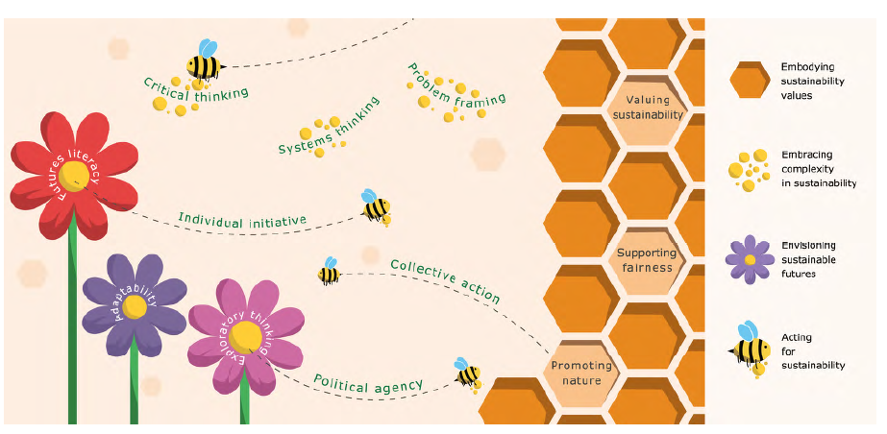
Figure 2: Visual representation of GreenComp

The European Commission has developed EntreComp: the European Entrepreneurship Competence Framework as a reference framework to explain what is meant by an entrepreneurial mindset. EntreComp is a common reference framework that identifies 15 competences in three key areas that describe what it means to be entrepreneurial. Figure 3 depicts the EntreComp competences as slices of a pie chart. Each slice has a different colour: blue for the competences in the ‘Ideas and opportunities’ area, orange for those in the ‘Resources’ area and green for the competences in the ‘Into action’ area. The slices are surrounded by the three competence rings, which embrace all the 15 competences.
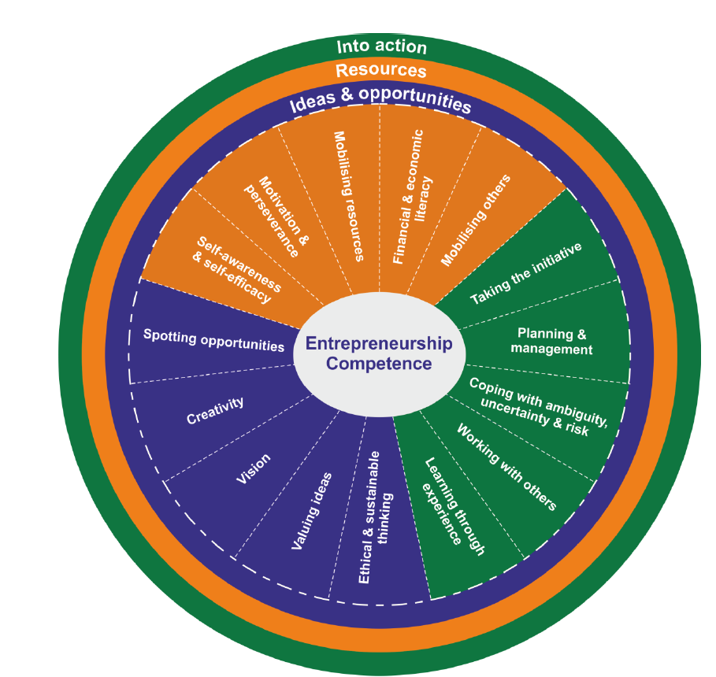
Figure 3: Areas and competences of the EntreComp conceptual model.

The Digital Competence Framework for Citizens, also known as DigComp, provides a common language to identify and describe the key areas of digital competence. Digital competence is part of the Key Competence Framework for Lifelong Learning and interlinked with other competences.

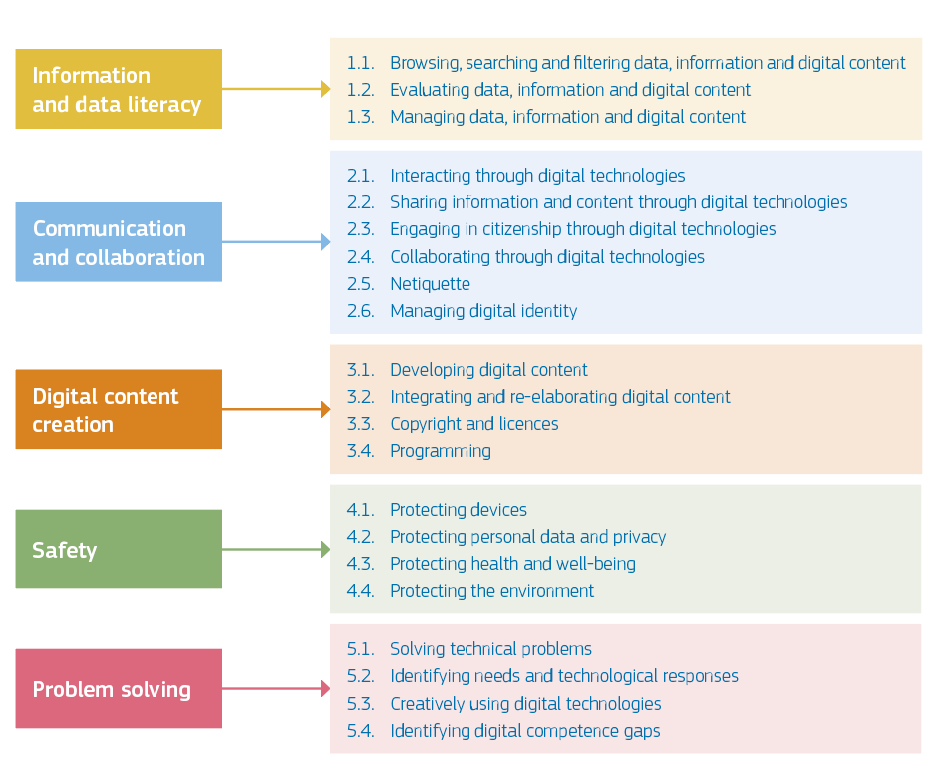
Figure 4.: The DigComp conceptual reference model

Ten competences of a Local Community Animator

Community animators have a wide range of responsibilities, which can include:
- Communicating with community members to understand their needs and concerns
- Creating outreach plans to help spread awareness of community issues or initiatives
- Coordinating volunteers and other members of the community to participate in events or projects that support the organization’s goals
- Building relationships with businesses, community leaders, and other groups that can be helpful in achieving the organization’s goals
- Conducting research on issues and possible solutions, such as environmental concerns or community safety issues
- Working with government agencies to improve public policy and create change through legislation or other means
- Implementing programs designed to empower members of the community to act on local issues such as crime prevention or education
- Planning community events such as festivals or block parties to engage residents in activities that promote social interaction with others in the community
- Identifying community needs and developing plans to address those needs through cooperation with other organizations.

In everyday working life, they carry out a wide range of activities, the work is not monotonous. They build organizations to maximize the power and involvement of their members. They listen to their members (through individual conversations). They are responsible for sharing information and raising issues, options, alternatives, and problems that affect the collective power that the group can wield. They identify and develop a diverse group of members who agree with the role of the organization's public voice on a variety of issues. They develop sound organizational strategies based on an analysis of power. Their task is also to recruit and develop leaders and group members. The role of the animator is to build public relationships. They work with people to define problems and issues and help them think about the strategies and tactics needed to act confidently and win. They help with fundraising and integrate fundraising into every aspect of their organizational work. Sometimes, they facilitate trainings and strategy sessions when needed. They strive for accountability and demand accountability from others in every aspect of their work.
The characteristics of a successful Community Animator are not prescribed, nor should they be. You’ll be an individual, with a unique set of skills and qualities which will make you fit for the job. You will also require learning new skills and you’ll never know it all – but you’ll journey in a spirit of learning, be open to new possibilities and be as humble as you are confident.
Based on the analysis of the responsibilities of a local community animator, his/her daily activities, we propose a set of 10 competences that are crucial for his/her work and successful career. In formulating the competencies, we have drawn on several occupational frameworks.
The individual competencies are complementary, sometimes overlapping (e.g. creativity and problem solving, leadership skills and strategic thinking), and together create a strong competency profile for anyone who wants to experience success in working with the community.
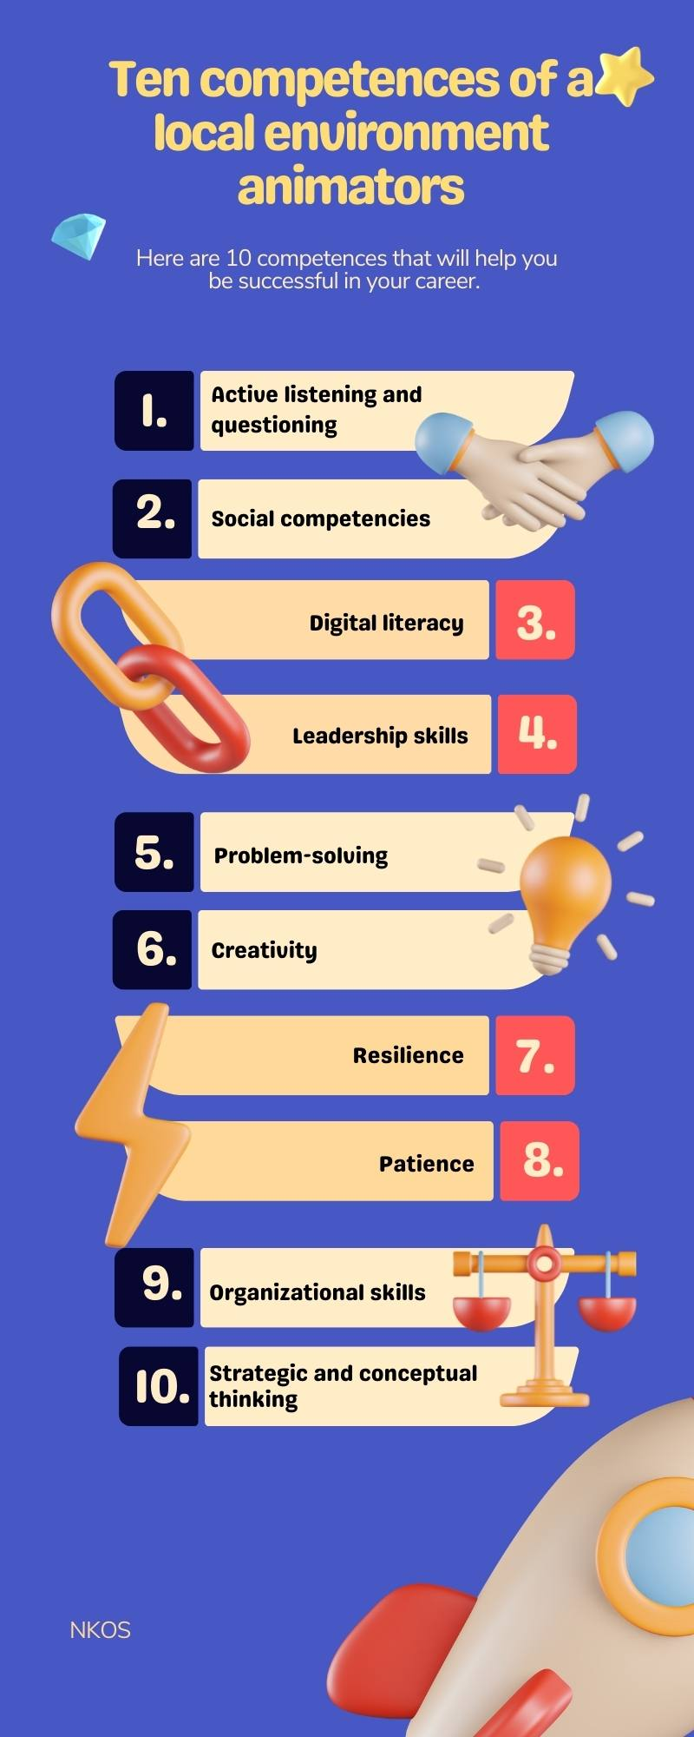
Figure 5. Ten competences of a Local Community Animator

1. Active listening and questioning
Comstock (2015) defines active listening as a communication technique that requires the listener to attend and focus on a speaker or group to understand the message. Listening requires concentration, not interrupting the speaker. According to authors Jones and Pfieffe (1998) active listening „is a matter of attitude and also an intellectual and emotional process “. Active listening is an important social skill used by the local animator to make the client feel understood and supported. This skill is important in community work, where clients often do not hear by the majority. In community work, it is very valuable that active listening maintains communication relationships and contributes to mitigating conflicts that are very common in communities. It can be, for example, an area of ​​negotiation between the client and his employer. The worker actively listens to both sides to provide the client with the necessary resources to fulfill his needs and solve his social problems. An animator can also teach the client the skills of active listening which can increase the quality of their life. To understand the client´s message well, it is necessary to use questioning to get feedback. Active listening requires listening to the content, intention and feeling of the client of community center. An animator as an active listener shows his interest to his client verbally with questions and with non-verbal, visual cues signifying that the other person has something important to say. Asking questions is related to active listening because it develops the conversation, helps the animator to understand the situation and gain new insights.

2. Social competencies
The application of a variety of complex abilities for creating and effectively managing social connections and interactions with others is referred to as social competence. Working in the local community will test the animator's level of social competences.
The individual can interact effectively with other people and build teamwork. Can use own strengths, balancing and complementing the strengths and weaknesses of others to effectively achieve goals. Respects ethical values and generally accepted standards of behavior, can accept difference, be tolerant, polite, courteous, and considerate. Can establish and maintain relationships, create, and use networks of contacts. He/she can identify conflict situations, assess the situation in conflict management, devise appropriate resolution strategies, minimize dysfunctions, and promote constructive dialogue. Can behave assertively and use effective communication.

3. Digital literacy
The local animator influences the community in a face-to-face way, but part of his/her work takes place in the digital environment. He or she manages a social media page or group or chat app, creates posters, online petitions or produces media content.
The updated DigComp 2.0 framework identifies key components of digital competence in five areas, which can be summarized as follows:
- Information and data literacy: articulate information needs, locate and retrieve digital data, information, and content. Assess the relevance of a resource and its content. Store, manage and organize digital data, information, and content.
- Communication and Collaboration: interact, communicate, and collaborate through digital technologies, being aware of cultural and generational diversity. Engage with society through public and private digital services and participatory citizenship. Manage our digital identity and reputation.
- Creating digital content: create and edit digital content Enhance and integrate information and content into the existing body of knowledge while understanding how copyright and licensing should be applied. Know how to give clear instructions for a computer system.
- Security: To protect devices, content, personal information, and privacy in digital environments. To protect physical and mental health and to know digital technologies for social well-being and social inclusion. To be aware of the environmental impact of digital technologies and their use.
- Problem Solving: Identify needs and problems and address conceptual issues and problem situations in digital environments. Use digital tools to innovate processes and products. To keep up to date with digital developments.

4. Leadership skills
The traits and talents that people exhibit to manage the resources, oversee initiatives, and influence members of their community toward the accomplishment of shared objectives are known as leadership skills. From the perspective of a local community animator, we look particularly at community leadership. Whereas animators of local environment may not have a formal leadership role, they nonetheless have an impact on their networks and contacts.
The roles of local animators as leaders include:
- Initiation and spread of interest
- Organization of sponsorship
- Goal setting and strategy formulation
- Recruitment – resource mobilization
- Implementation of strategy and plans.
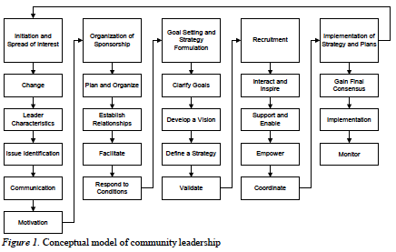
Figure 6. Conceptual model of community leadership.

5. Problem solving
The process of detecting a problem, coming up with potential solutions, and taking the right action is known as problem solving. Your personal and professional lives both benefit from having strong problem-solving abilities. Managers frequently cite everyday problem solving as essential to the success of their organizations in the rapidly changing world of today. Local environment coordinators might use problem-solving to come up with useful and original solutions as well as to demonstrate independence and initiative to employers.
The ability to solve problems is a skill, and just like any other skill, the more you practice, the better you get. So how exactly do you practice problem solving? Learning about different problem-solving strategies and when to use them will give you a good start.
The problem-solving process is structured as shown in the following figure 7.
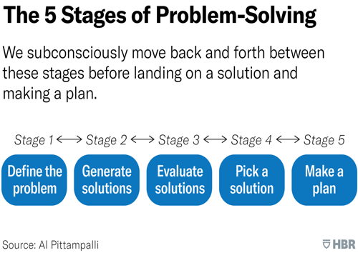
Figure 7. The five stages of problem solving.

6. Creativity
Creativity is not a mysterious, magical process that is only available to a select group of people, such as singers, actors, writers, and artists. People have trouble defining creativity precisely. The capacity to switch between wonder and rigor to solve issues and offer unique value is creativity. Our ability for wonder allows us to pause, fantasize, and pose bold, imaginative questions. Rigor is the ability to follow rules, use complex abilities, pay close attention to details, and devote sufficient time to a task to master it. Both are essential for the development of creativity. A hybrid approach to creativity that blends awe and analytical rigor is essential to succeed in our age of augmented reality, artificial intelligence, and quickly developing technologies.
The ability to combine previously learned information to solve issues and create new things is what makes creativity fundamentally a combinatorial process. The work of a local community animator is not routine. An animator experiences new situations and challenges and innovates while overcoming them.

7. Resilience
Resilience can be defined as „capacity of individuals to withstand considerable hardship, to bounce back in the face of adversity, and to go on to live functional lives with a sense of well-being“. Among the qualities that build resilience that does not suppress reality, but accepts it, are: „A sense of humor; a sense of direction or mission; intellectual capacity; adaptive distancing; self-efficacy (or self-esteem and initiative); and the possession of a talent or skill“. Resilience does not depend on the conditions in which the animator finds himself and which he faces. Even in adverse life circumstances, a person can remain resistant to them and live a functional life full of well-being. Resilience as a specific ability of a professional does not mean avoiding anxiety, fear or uncertainty. Resilience is about overcoming them.
„Cultivating resilience allows us to face these and other stressful experiences with greater confidence, so we have the resources to bounce back“. In community work, animator often come across imperfect systems and financing of social services. Their persistence, steadfastness is needed. A local coordinator in the community not only builds their own resilience, but also builds "community resilience". By this we mean strengthening social capital, networks, and support; language revitalization, strengthening of cultural identity and spirituality; supporting families and parents to ensure the healthy development of the child; improving local control and collective efficiency; building infrastructure (material, human and informational); increasing economic opportunities and diversification; and respecting human diversity.
Working with excluded clients brings situations of frustration, so resilience is important to keep the local animator motivated.

8. Patience
Local animators must exercise tolerance and patience in different situations or in handling difficult persons.
In the present fast-changing environment with accelerated pace of living and with greater dependence upon technology, this skill is becoming alien among people. Present-day clients want speedy and spontaneous service without losing time, and services cannot afford losing “customers" and referral opportunities. If animators do not exercise patience in such situations, negative emotions accelerate, and relations get destroyed. Animators must demonstrate patience in such type of difficult situations by taking fair and firm actions.
“Patient people understand that the more they accept the things they can't change, such as events they can't control, the more they can learn to react in a way that doesn't maximize stress or make the situation worse… Patience doesn't mean you never feel frustrated, but it does mean you know how to handle frustration and grant allowances for it. You can avoid making decisions based on the anger or frustration you feel. Developing patience can take some practice”.

9. Organizational skills
Organization skills are those related to creating structure and order, boosting productivity, and prioritizing tasks “that must be completed immediately, versus those that can be postponed, delegated to another person, or eliminated altogether. Maintaining strong organizational skills can reduce the chance of developing poor work habits such as procrastination, clutter, miscommunication, and inefficiency. Managers usually look for employees who can not only keep their work and their desk organized, but for those who can also adjust quickly to the organizational structure of a company”.
Organizational skills also include time management. A community animator must plan different types of activities and manage his/her time effectively.
These skills are valuable, so it is advisable for local coordinators to acquire them. The good news is that organizational skills can be learned and developed.

10. Strategic and conceptual thinking
Strategic thinking skills are any skills that enable animators to use critical thinking to solve complex problems and plan for the future. These skills are essential to accomplish job objectives, overcome obstacles, and address challenges—particularly if they’re projected to take weeks, months, or even years to achieve.
Animators must “define significant problems, gather information, formulate ideas, and construct prototype plans for solving the problem. These complex, creative problem-solving skills imply a need for expertise bearing on both the nature of the problem and the kind of leadership role at hand”.
Conceptual skills help workers avoid the pitfall of not “seeing the forest for the trees,” as the saying goes. If they possess conceptual skills, they can both envision problems and brainstorm solutions. Having these skills likely means that they're creative types and can work through abstract concepts and ideas.
Conceptual thinkers are adept at grasping the rationale behind actions. They have the ability to think abstractly and quickly apply what they learn to a given circumstance. To compete in a varied culture, animators will need to think creatively about all aspects. You will learn how to concentrate on the larger picture and spot implicit concepts before others do through the assignments in this competency course.

References
Amico, L. 2021. How to Solve Problems. Harward Business Review. Retrieved September 17, 2022, from https://hbr.org/2021/10/how-to-solve-problems
Bacigalupo M, Kampylis P, Punie Y and Van Den Brande L. EntreComp: The Entrepreneurship Competence Framework. EUR 27939 EN. Luxembourg (Luxembourg): Publications Office of the European Union; 2016. JRC101581
Bauer C, Kathrin F, Renate MP. 2010. Introducing “active listening” to instant messaging and e-mail: benefits and limitations. IADIS International Journal on WWW/Internet. 7(2), 1–17.
Bianchi, G., Pisiotis, U. and Cabrera Giraldez, M., GreenComp The European sustainability competence framework, Punie, Y. and Bacigalupo, M. editor(s), EUR 30955 EN, Publications Office of the European Union, Luxembourg, 2022, ISBN 978-92-76-46485-3, doi:10.2760/13286, JRC128040.
Career Insights. 2022. What Does a Community Organizer Do? Retrieved September 17, 2022, from https://climbtheladder.com/community-organizer/
COM (2009) 640 final. Key competences for a changing world. https://eur-lex.europa.eu/LexUriServ/LexUriServ.do?uri=COM:2009:0640:FIN:EN:PDF accessed: 25.07.2022
COMIT. n. d. Introduction to Problem Solving Skills. Retrieved September 17, 2022, from https://ccmit.mit.edu
Competence and competency frameworks. 2019 https://www.cipd.co.uk/knowledge/fundamentals/people/performance/competency-factsheet#gref accessed: 25.07.2022
Comstock, N. W. 2015. Active listening. Amenia, NY: Salem Press Encyclopedia
Doyle, A. 2021. Top Organizational Skills Employers Value with Examples. The Balance Careers. Retrieved September 17, 2022, from https://www.thebalancecareers.com/organizational-skills-list-2063762
Gavin, H. et all n. d. Unlocking Potential. A Handbook for Community Animators. Retrieved September 17, 2022, from https://www.sup.org.uk/PDF/A-Handbook-for-Community-Animators.pdf
Herrity, J. 2019. The Importance of Being Patient and How To Develop Patience. Indeed Career Guide. Retrieved September 17, 2022, from https://www.indeed.com/career-advice/career-development/being-patient
House of Commons Women and Equalities Committee. 2019. Tackling inequalities faced by Gypsy, Roma and Traveller communities. Seventh Report of Session 2017–19.
Hunsaker PL, Alessandra T, Alessandra AJ. 2008. The new art of managing people, updated and revised: Person-to-person skills, guidelines, and techniques every manager needs to guide, Direct, and Motivate the Team. Simon and Schuster Inc; New York.
James, M. n. d. Conceptual Skills: Definition, Overview and Examples. Career Support. Retrieved September 17, 2022, from https://carreersupport.com/conceptual-skills-definition-overview-and-examples/
Jones JE, Pfieffe JW. The 1974 Annual Handbook for Group Facilitators. San Diego, CA: Pfieffer; 1974. Small Group Instructor Training Course (SGITC). 1998. By U. S. Army.
Kirmayer, L. J., Sedhev, M., Whitley, R., Dandeneau, S., & Isaac, C. 2009. Community resilience: Models, metaphors and measures. In Journal of Aboriginal Health, 7(1), 62-117.
Kumar, V., & Dhiman, S. 2022. Transcending Emerging Barriers Through Patience. In Innovative Leadership in Times of Compelling Changes (pp. 79-98). Springer, Cham.
Lamm, K. W., Carter, H. S., Lamm, J., Lindsey A. B. 2017. Community Leadership: A Theory-Based Model. Journal of Leadership Education, 16(3), 118-133
Mumford, M. D., Zaccaro, S. J., Connelly, M. S., & Marks, M. A. 2000. Leadership skills: Conclusions and future directions. The Leadership Quarterly, 11(1), 155-170.
Nixon, N. 2020. Creative Competency: Why to Make It Everyone’s Priority for Your Business. In: CEOWorld Magazine. Retrieved September 17, 2022, from https://ceoworld.biz/2020/06/24/creative-competency-why-to-make-it-everyones-priority-for-your-business/
Nowak, I. 2018. Ako robiť sociálne zmeny v lokálnych komunitách - príručka pre komunitných organizátorov. Banská Bystrica: Centrum komunitného organizovania
Rodat, S. 2020. Empathy and active listening in the humanistic social work. Research Terminals in the Social Sciences (eds. Dan Valeriu Voinea and Alexandru Strungă) (pp.9-25) SITECH Publishing House, Craiova.
Sala, A., Punie, Y., Garkov, V. and Cabrera Giraldez, M., LifeComp: The European Framework for Personal, Social and Learning to Learn Key Competence, EUR 30246 EN, Publications Office of the European Union, Luxembourg, 2020, ISBN 978-92-76-19418-7, doi:10.2760/302967, JRC120911.
Scott, D. 2015. New Perspectives on Curriculum, Learning and Assessment. Springer. ISBN 3319228315
Sharkey, S., Sharples, A. 2008. From the Beginning. In Evaluation, 14(3), 363–380. doi:10.1177/1356389008090860
Slovak National Framework of Occcupations. Retrieved September 17, 2022, from https://www.sustavapovolani.sk
Stobierski, T. 2020. 4 Ways To Develop Your Strategic Thinking Skills. Harward Business School Online. Retrieved September 17, 2022, from https://online.hbs.edu/blog/post/how-to-develop-strategic-thinking-skills
Švehláková, B. 2020. Komunikačné zručnosti a aktívne počúvanie. In Direktor. Portál pre riaditeľov škôl a zriaďovateľov. ISSN 1339-925X.
Turner, S. G. 2001. Resilience and Social Work Practice: Three Case Studies. Families in Society: The Journal of Contemporary Social Services, 82(5), 441–448.
Zahra, M.,B. .2019. The importance of knowledge, skills and abilities. https://surgeadvisory.com/development/the-importance-of-knowledge-skills-and-abilities/ accessed: 25.07.2022
Vaillant, G. E. 1993. The wisdom of the ego. Cambridge, MA: Harvard University Press.
Vuorikari, R., Kluzer, S. and Punie, Y., DigComp 2.2: The Digital Competence Framework for Citizens - With new examples of knowledge, skills and attitudes, EUR 31006 EN, Publications Office of the European Union, Luxembourg, 2022, ISBN 978-92-76-48882-8 (online),978-92-76-48883-5 (print), doi:10.2760/115376 (online),10.2760/490274 (print), JRC128415.
Whitney E. 2017. Resilience for Social Workers: How To Increase Flexibility, Energy, and Engagement in the Face of Challenge. In: The New Social Worker. Harrisburg.
Winterton, J. .2006. Typology of knowledge, skills and competences: clarification of the concept and prototype. European Centre for the Development of Vocational Training. Luxemburg. ISBN 92-896-0427-1 https://www.cedefop.europa.eu/files/3048_en.pdf accessed: 25.07.2022
Winterton, Jonathan & Delamare, Françoise & Deist, Le & Stringfellow, Emma. 2005. Typology of Knowledge, Skills and Competences: Clarification of the Concept and Prototype.

Winterton, J. .2006. Typology of knowledge, skills and competences: clarification of the concept and prototype. European Centre for the Development of Vocational Training. Luxemburg. ISBN 92-896-0427-1 https://www.cedefop.europa.eu/files/3048_en.pdf accessed: 25.07.2022
Zahra, M.,B. .2019. The importance of knowledge, skills and abilities. https://surgeadvisory.com/development/the-importance-of-knowledge-skills-and-abilities/ accessed: 25.07.2022
Competence and competency frameworks. 2019 https://www.cipd.co.uk/knowledge/fundamentals/people/performance/competency-factsheet#gref accessed: 25.07.2022
Scott, D. 2015. New Perspectives on Curriculum, Learning and Assessment. Springer. ISBN 3319228315
Winterton, Jonathan & Delamare, Françoise & Deist, Le & Stringfellow, Emma. (2005). Typology of Knowledge, Skills and Competences: Clarification of the Concept and Prototype.
COM(2009)640 final. Key competences for a changing world. https://eur-lex.europa.eu/LexUriServ/LexUriServ.do?uri=COM:2009:0640:FIN:EN:PDF accessed: 25.07.2022
Sala, A., Punie, Y., Garkov, V. and Cabrera Giraldez, M., LifeComp: The European Framework for Personal, Social and Learning to Learn Key Competence, EUR 30246 EN, Publications Office of the European Union, Luxembourg, 2020, ISBN 978-92-76-19418-7, doi:10.2760/302967, JRC120911.
Sala, A., Punie, Y., Garkov, V. and Cabrera Giraldez, M., LifeComp: The European Framework for Personal, Social and Learning to Learn Key Competence, EUR 30246 EN, Publications Office of the European Union, Luxembourg, 2020, ISBN 978-92-76-19418-7, doi:10.2760/302967, JRC120911.
Bianchi, G., Pisiotis, U. and Cabrera Giraldez, M., GreenComp The European sustainability competence framework, Punie, Y. and Bacigalupo, M. editor(s), EUR 30955 EN, Publications Office of the European Union, Luxembourg, 2022, ISBN 978-92-76-46485-3, doi:10.2760/13286, JRC128040.
Bianchi, G., Pisiotis, U. and Cabrera Giraldez, M., GreenComp The European sustainability competence framework, Punie, Y. and Bacigalupo, M. editor(s), EUR 30955 EN, Publications Office of the European Union, Luxembourg, 2022, ISBN 978-92-76-46485-3, doi:10.2760/13286, JRC128040.
Bacigalupo M, Kampylis P, Punie Y and Van Den Brande L. EntreComp: The Entrepreneurship Competence Framework. EUR 27939 EN. Luxembourg (Luxembourg): Publications Office of the European Union; 2016. JRC101581
Bacigalupo M, Kampylis P, Punie Y and Van Den Brande L. EntreComp: The Entrepreneurship Competence Framework. EUR 27939 EN. Luxembourg (Luxembourg): Publications Office of the European Union; 2016. JRC101581.
Vuorikari, R., Kluzer, S. and Punie, Y., DigComp 2.2: The Digital Competence Framework for Citizens - With new examples of knowledge, skills and attitudes, EUR 31006 EN, Publications Office of the European Union, Luxembourg, 2022, ISBN 978-92-76-48882-8 (online),978-92-76-48883-5 (print), doi:10.2760/115376 (online),10.2760/490274 (print), JRC128415.
Vuorikari, R., Kluzer, S. and Punie, Y., DigComp 2.2: The Digital Competence Framework for Citizens - With new examples of knowledge, skills and attitudes, EUR 31006 EN, Publications Office of the European Union, Luxembourg, 2022, ISBN 978-92-76-48882-8 (online),978-92-76-48883-5 (print), doi:10.2760/115376 (online),10.2760/490274 (print), JRC128415.
Career Insights. 2022. What Does a Community Organizer Do? Retrieved September 17, 2022, from https://climbtheladder.com/community-organizer/
Nowak, I. 2018. Ako robiť sociálne zmeny v lokálnych komunitách - príručka pre komunitných organizátorov. Banská Bystrica: Centrum komunitného organizovania, p.70
Gavin, H. et all n. d. Unlocking Potential. A Handbook for Community Animators. Retrieved September 17, 2022, p.16 from https://www.sup.org.uk/PDF/A-Handbook-for-Community-Animators.pdf
Hunsaker PL, Alessandra T, Alessandra AJ. 2008. The new art of managing people, updated and revised: Person-to-person skills, guidelines, and techniques every manager needs to guide, Direct, and Motivate the Team. Simon and Schuster Inc; New York.
House of Commons Women and Equalities Committee. 2019. Tackling inequalities faced by Gypsy, Roma and Traveller communities. Seventh Report of Session 2017–19. p.9
Rodat, S. 2020. Empathy and active listening in the humanistic social work. Research Terminals in the Social Sciences (eds. Dan Valeriu Voinea and Alexandru Strungă) (pp.9-25) SITECH Publishing House, Craiova.
Sharkey, S., Sharples, A. 2008. From the Beginning. In Evaluation, 14(3), 363–380. doi:10.1177/1356389008090860
Švehláková, B. 2020. Komunikačné zručnosti a aktívne počúvanie. In Direktor. Portál pre riaditeľov škôl a zriaďovateľov. ISSN 1339-925X.
Bauer C, Kathrin F, Renate MP. 2010. Introducing “active listening” to instant messaging and e-mail: benefits and limitations. IADIS International Journal on WWW/Internet. 7(2), 1–17.
Slovak National Framework of Occcupations. Retrieved September 17, 2022, from https://www.sustavapovolani.sk
Vuorikari, R., Punie, Y., Carretero, S. and Brande, L., 2016. DigComp 2.0. Luxembourg: EU, Publications Office.
Lamm, K. W., Carter, H. S., Lamm, J., Lindsey A. B. 2017. Community Leadership: A Theory-Based Model. Journal of Leadership Education, 16(3), 118-133
Lamm, K. W., Carter, H. S., Lamm, J., Lindsey A. B. 2017. Community Leadership: A Theory-Based Model. Journal of Leadership Education, 16(3), 118-133
COMIT. n. d. Introduction to Problem Solving Skills. Retrieved September 17, 2022, from https://ccmit.mit.edu
Amico, L. 2021. How to Solve Problems. Harward Business Review. Retrieved September 17, 2022, from https://hbr.org/2021/10/how-to-solve-problems
Nixon, N. 2020. Creative Competency: Why to Make It Everyone’s Priority for Your Business. In: CEOWorld Magazine. Retrieved September 17, 2022, from https://ceoworld.biz/2020/06/24/creative-competency-why-to-make-it-everyones-priority-for-your-business/
Vaillant, G. E. 1993. The wisdom of the ego. Cambridge, MA: Harvard University Press. p.248
Turner, S. G. 2001. Resilience and Social Work Practice: Three Case Studies. Families in Society: The Journal of Contemporary Social Services, 82(5), 441–448. p. 442
Turner, S. G. 2001. Resilience and Social Work Practice: Three Case Studies. Families in Society: The Journal of Contemporary Social Services, 82(5), 441–448.
Whitney E. 2017. Resilience for Social Workers: How To Increase Flexibility, Energy, and Engagement in the Face of Challenge. In: The New Social Worker. Harrisburg. p.3
Kirmayer, L. J., Sedhev, M., Whitley, R., Dandeneau, S., & Isaac, C. 2009. Community resilience: Models, metaphors and measures. In Journal of Aboriginal Health, 7(1), 62-117.
Kumar, V., & Dhiman, S. 2022. Transcending Emerging Barriers Through Patience. In Innovative Leadership in Times of Compelling Changes (pp. 79-98). Springer, Cham. p.83
Herrity, J. 2019. The Importance of Being Patient and How To Develop Patience. Indeed Career Guide. Retrieved September 17, 2022, from https://www.indeed.com/career-advice/career-development/being-patient
Doyle, A. 2021. Top Organizational Skills Employers Value with Examples. The Balance Careers. Retrieved September 17, 2022, from https://www.thebalancecareers.com/organizational-skills-list-2063762
Stobierski, T. 2020. 4 Ways To Develop Your Strategic Thinking Skills. Harward Business School Online. Retrieved September 17, 2022, from https://online.hbs.edu/blog/post/how-to-develop-strategic-thinking-skills
Mumford, M. D., Zaccaro, S. J., Connelly, M. S., & Marks, M. A. 2000. Leadership skills: Conclusions and future directions. The Leadership Quarterly, 11(1), 155-170.
James, M. n. d. Conceptual Skills: Definition, Overview and Examples. Career Support. Retrieved September 17, 2022, from https://carreersupport.com/conceptual-skills-definition-overview-and-examples/

